# Functional Modeling

This section of the document will model the functional requirements of the Book Inventory System (BIS) based on the following use cases:

* Adding a Book Record
* Adding a Non-Book Record
* Removing a Record
* Adjusting a Record
* Listing All Records of a Given Type
* Searching for a Record

## Adding a Book Record

Functional Requirement Modeled: FR1 – Manipulate a Record

The following use case diagram displays the process of adding a book record to the BIS. This type of record is distinct from the process of adding all other types of records because this is the only type of record for which the key data member is not automatically generated to prevent conflicts.

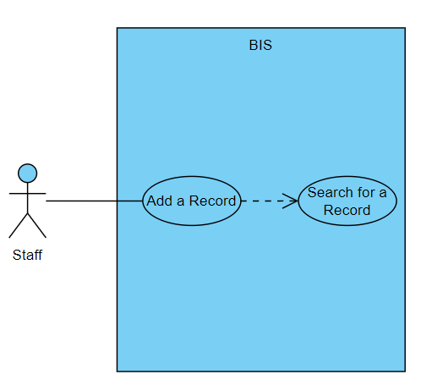

The following procedure describes the creation of a new book record. The key data member for this kind of record is the ISBN. The ISBN can only contain numbers, and it must be exactly 10 or 13 digits long based on the standards established for ISBNs by the authority organization, the International ISBN Agency. Each book record must include a non-negative, numerical Store Price for the book.

#### Normal Scenario

1. Staff enters the new record’s key data member, the ISBN.
2. BIS validates the ISBN against the expected format.
3. BIS searches the existing book records by ISBN to verify that the ISBN is not already in use.
4. Staff enters information for all of the book’s remaining mandatory data members: Title, at least one Author, Format, Edition, Store Price, and Stock quantity.
5. BIS validates the Store Price against the expected format.
6. BIS creates a new book record with this information.

#### Exception Scenario – Key Data Member Conflicts with An Existing Record

1. Staff enters the new record’s key data member, the ISBN.
2. BIS validates the ISBN against the expected format.
3. BIS searches the existing book records and discovers one that already uses that ISBN.
4. BIS displays the existing book record with a message informing the user that the ISBN provided is already in use.

#### Exception Scenario – Invalid Data for Key Data Member

1. Staff enters the new record’s key data member, the ISBN.
2. BIS fails to validate the ISBN against the expected format.
3. BIS displays an error message informing the user that the ISBN does not meet validation requirements in terms of either limits or content as appropriate.

#### Exception Scenario – Invalid Data for Store Price

1. Staff enters the new record’s key data member, the ISBN.
2. BIS validates the ISBN against the expected format.
3. BIS searches the existing book records by ISBN to verify that the ISBN is not already in use.
4. Staff enters information for all of the book’s remaining mandatory data members: Title, at least one Author, Format, Edition, Store Price, and Stock quantity.
5. BIS fails to validate the Store Price against the expected format.
6. BIS displays an error message informing the user that the Store Price does not meet validation requirements in terms of a non-zero value.,

## Adding a Non-Book Record

Functional Requirement Modeled: FR1 – Manipulate a Record

The following use case describes the process of adding a non-book record to the BIS. The three subsections following that breakdown the general procedure of adding each of the three non-book types of records supported by the product: customers, employees, and orders.

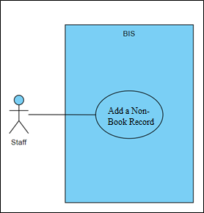

### Adding a Customer Record

This procedure describes the creation of a new customer record. The key data member for this kind of record is the Customer Number. This data member contains only numbers and is ten digits in length. It is assigned automatically by the system to preempt possible conflicts.

#### Normal Scenario

1. BIS auto-fills the new Employee Number, one higher than the most recent prior Employee Number entered.
2. Staff selects if the customer is an individual or a business, which determines whether the record requires a First Name and Last Name or a Business Name.
3. Staff enters information for the customer’s remaining mandatory data members: First/Last Name or Business Name, Mailing Address, Phone Number, and Email Address.
4. BIS creates a new customer record with this information.

### Adding an Employee Record

This procedure describes the creation of a new employee record. The key data member for this type of record is the Employee Number. This data member contains only numbers and is ten digits in length.

#### Normal Scenario

1. BIS auto-fills the new Employee Number, one higher than the most recent prior Employee Number entered.
2. Staff enters information for the employee’s remaining mandatory data members: First Name, Last Name, Mailing Address, Phone Number, and Email Address.
3. BIS creates a new employee record with this information.

### Adding an Order Record

This procedure describes the creation of a new customer record. The key data member for this record is the Order Number, which contains only numbers and is ten digits in length. Each record must also provide a valid Employee Number and at least one book. Books in orders must include an ISBN and an Order Quantity above 0.

#### Normal Scenario

1. BIS auto-fills the new Order Number, one higher than the most recent prior Order Number entered.
2. Staff enters their assigned Employee Number.
3. BIS validates the Employee Number against the expected format.
4. BIS searches employee records for one with a matching Employee Number.
5. Staff enters the information for the order’s Contents, including at least one ISBN with a non-zero quantity.
6. BIS validates each ISBN and order quantity in the order’s Contents against expected formats.
7. BIS searches the book records by ISBN to verify that each book exists in the system and that there is a sufficient Stock quantity to satisfy the order.
8. Staff enters the information for the order’s optional data member, the Customer Number.
9. BIS validates the Customer Number against the expected format as applicable.
10. BIS searches the customer records by Customer Number to verify a customer with that number exists in the system.
11. BIS creates a new order record with this information.
12. BIS decreases the Stock quantity for each book sold as part of the order Contents accordingly.

#### Exception Scenario – Invalid Employee Number

#### Exception Scenario – Invalid ISBN or Quantity for Book in Order Contents

#### Exception Scenario – Insufficient Stock Quantity for Book in Order Contents

#### Exception Scenario – Invalid Customer Number

## Removing a Record

Functional Requirement Modeled: FR1 – Manipulate a Record

The following use case diagram displays the process of removing a record from the BIS. The four subsections following that breakdown the general procedure of removing each of the four types of records supported by the product: books, customers, employees, and orders.

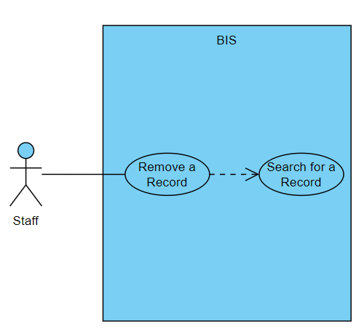

### Removing a Book Record

This procedure describes the removal of an existing book record from the system.

### Removing a Customer Record

This procedure describes the removal of an existing customer record from the system.

### Removing an Employee Record

This procedure describes the removal of an existing employee record from the system.

### Removing an Order Record

This procedure describes the removal of an existing order record from the system.

## Adjusting a Record

Functional Requirement Modeled: FR1 – Manipulate a Record

The following use case diagram displays the process of adjusting a record already in the BIS. The four subsections following that breakdown the general procedure of adjusting each of the four types of records supported by the product: books, customers, employees, and orders.

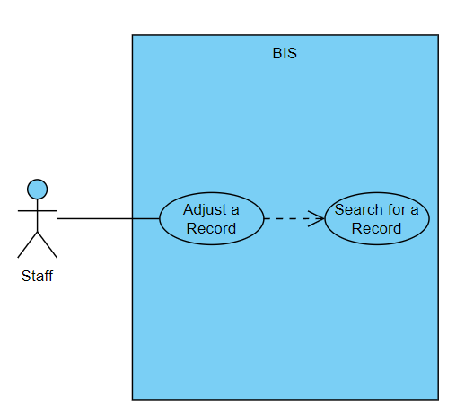

### Adjusting a Book Record

This procedure describes the adjustment of any property of any existing book record. The most frequent application of this use case involves adjusting the stock quantity or price of a book.

### Adjusting a Customer Record

This procedure describes the adjustment of any property of any existing customer record.

### Adjusting an Employee Record

This procedure describes the adjustment of any property of any existing employee record.

### Adjusting an Order Record

This procedure describes the adjustment of any property of any existing order record.

## Listing All Records of a Given Type

Functional Requirement Modeled: FR2 – Print List of Records

This use case analyzes the generation of a report listing all records of a single type.

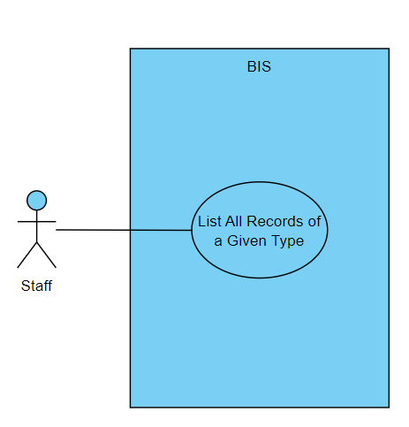

## Searching for a Record

Functional Requirement Modeled: FR3 – Search for a Record

The following use case diagram displays the process of searching for a record in the BIS. The four subsections following that breakdown the general procedure of searching for each of the four types of records supported by the product: books, customers, employees, and orders.

### Searching for a Book Record

This procedure describes the process of searching for a book record with information such as the ISBN, title, or author.

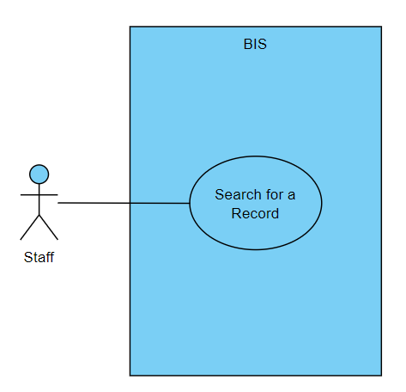

### Searching for a Customer Record

This procedure describes the process of searching for a customer record by Member Number.

### Searching for an Employee Record

This procedure describes the process of searching for an employee record by Employee Number.

### Searching for an Order Record

This procedure describes the process of searching for an order record by Order Number.